QS1.1 Makes Sense

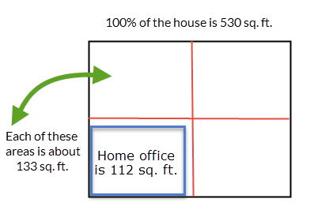

QS1.2 Makes sense

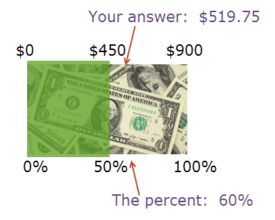

$433 $866

Your answer: $519.75

Percentage your landlord will pay: 60%

QS1.5

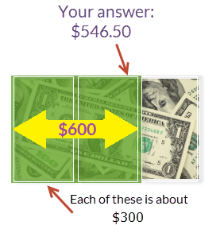

Each of these is   
about $300

$900

$0

QS1.3 Makes sense

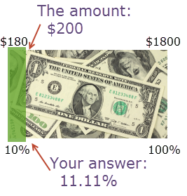

0% 10%

The amount of increase: $200

Your answer: 11.11%

$0 $180

QS 1.4 Make sense

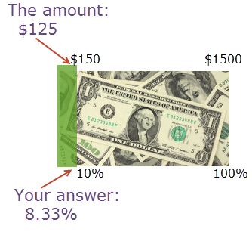

The amount of decrease: $125

Your answer: 8.33%

0% 10%

$0 $150

QS1.5 See above